

**Research & Vehicle Technology**

**“Product Development”**

**Enhanced Memory**

**Soft Button Specific Document**

Version 1.1

**UNCONTROLLED COPY IF PRINTED**

**Version Date: Feb 20, 2020**

**FORD CONFIDENTIALF**

# Feature Requirements

## Vehicle configure condition for this feature

### ENMEM-REQ-xxx1/B-Classic Memory scope condition

The vehicle shall be equipped with the classic memory which only include the mirrors and seat position (Such as CD542). If the vehicle’s classic memory is also including HUD and Steering column position, the feature spec shall do the specific modification for that.

### ENMEM-REQ-xxx2/B-Memory Button conditions

The vehicle’s memory button configuration shall consist of the Button1/Button2/Button3 (MemorySetSw_Cfg=Not Present, such as CD542), if the vehicle’s memory button consists of Button1/Button2/Button Set, the feature spec shall do the specific modification for that.

Also, this document only suitable for the program that replace the hard button with soft button on IVI.

## Functional Requirements

### ENMEM-REQ-199758/A-Associate Driver Profiles to a person index automatically

In profile create process, enhanced memory will assign a person index to driver profile according to the create order. Driver profile1/2/3 corresponding person index1/2/3.

If the profile changed, the person_index shall change accordingly. Also, if one profile deleted, the left profile shall keep their association with person_index.

# Functional Definition

## ENMEM-FUN-REQ-xxxxx – New Signals for SYNC+

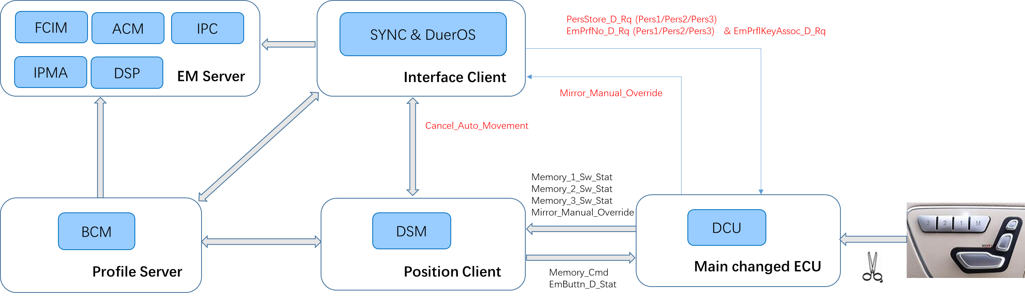

|  |  |  |  |
| --- | --- | --- | --- |
| No | Signal Name | Message | Comment |
| 1 | Cancel_Auto_Movement | 0x304, Driver_Seat_Information_2 | From DSM to DuerOS |
| 2 | Mirror_Manual_Override | 0x33A, Memory_Sw_StatM | From DCU to DuerOS |
| 3 | PersStore_D_Rq | 0x3E2, Personality_APIM_Data | From DuerOS to DCU |
| 4 | EmPrflNo_D_Rq | 0x227, APIM_Request_Signals_1 | From DuerOS to DCU |
| 5 | EmPrflKeyAssoc_D_Rq | 0x227, APIM_Request_Signals_1 | From DuerOS to DCU |

## ENMEM-FUN-REQ-199838/B-Create/Add Driver Profile

### Create/Add Driver Profile Function Description

An Enhanced Memory Driver Profile is a collection of personalized vehicle settings that can be recalled by a user. The Driver Profile creation process allows a user to name the Driver Profile and to associate the Driver Profile to a Driver Memory Seat button. The creation process also copies the current active vehicle settings to the created Driver Profile.

To create the first Driver Profile, the user is required to first opt-in to the Enhanced Memory feature. Once a Driver Profile is created, the user may add more Driver Profiles without having to opt-in again. During the creation process, the user also has an option to associate a keyfob and/or a phone to the newly created Driver Profile.

The Create/Add Driver Profile Function is an Enhanced Memory Logic Function that will support all the functionalities mentioned above.

The Create/Add Driver Profile Function can be triggered by the user or called by the Opt-In Function. This Function first will call the Create/Edit Name Function to obtain a unique Driver Profile Name from the user, then call the Associate Driver Memory Seat button Function to associate the new Driver Profile to an un-associated Driver Memory Seat button. The Create/Add Driver Profile Function calls the Copy Function to copy all current active settings to the new Driver Profile. The Create/Add Driver Function HMI will also solicit the user option for associating a keyfob and a phone and call the Associate Keyfob Function and/or Associate Phone Function when the user successfully chooses to associate a keyfob and/or a phone. The Create/Add Driver Profile Function then calls the Recall Driver Profile Function to recall the newly created Driver Profile for the user automatically.

|  |  |  |  |
| --- | --- | --- | --- |
| Create/Add Driver Profile Functional Decomposition Diagram | | | |
| HMI Menu Customer Function | Logic Function | | |
| Level1 | Level2 | Level3 |
| Opt-In | Opt-In | Create/Add Driver Profile | Create/Edit Name |
| Associate Driver Memory Seat Button Automatically |
| Copy |
| Recall Driver Profile |
| Add Driver Profile | Create/Add Driver Profile | Create/Edit Name |  |
|  | Associate Driver Memory Seat Button Automatically |
|  | Copy |
|  | Recall Driver Profile |

Figure 7 – Create/Add Driver Profile Functional Decomposition Diagram

The HMI flow chart below illustrates the HMI process of Create/Add Driver Profile that includes obtaining Driver Profile Name, Associating Driver Memory Seat button, waiting for Copy and the optional Keyfob Association and Phone Association steps.

Please note that this flow chart only serves as a design aid and does not necessarily represent the final implementation.

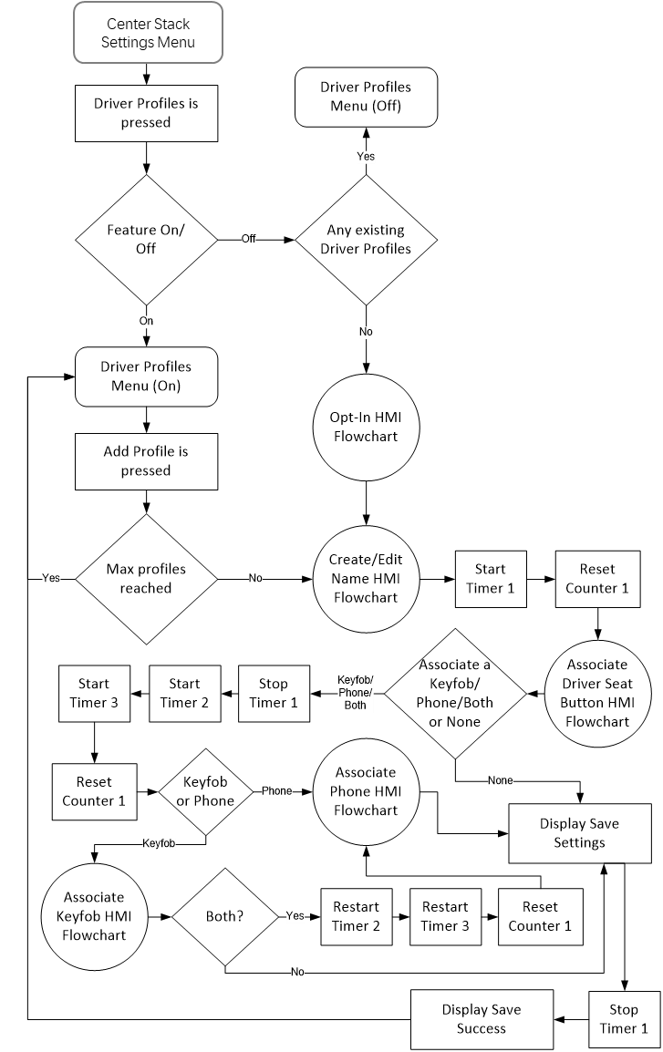

Figure 8 – Enhanced Memory Create/Add Profile HMI Flow Chart

### Use Cases

#### ENMEM-UC-REQ-199839/A-Create a Driver Profile

|  |  |
| --- | --- |
| **Actors** | Vehicle Occupant |
| **Pre-conditions** | The Ignition Status is in Run.  The vehicle transmission is in Park OR vehicle speed is less than the Driving Restriction threshold* for a manual transmission  The Enhanced Memory feature is enabled (set to On)  The maximum number of Driver Profiles has not yet been reached |
| **Scenario Description** | The User accesses the Enhanced Memory menu, chooses to create a new Driver Profile |
| **Post-conditions** | A new profile is created with:   * all applicable non-positional settings copied from the previous Driver Profile to the new Driver Profile * all applicable positional settings copied from the currently active settings (from previous Driver Profile, or from recently changed but not saved settings) to the new Driver Profile |
| **List of Exception Use Cases** |  |
| **Interfaces** | Personalization Interface |
| **Notes** | Available Driver Memory Seat buttons for association are defined in ENMEM-HMI-REQ-198876  *Driving Restriction threshold is defined in DRIVE-RESv2-FUR-REQ-025157-HMI Driving Restriction. |

#### ENMEM-UC-REQ-199850/A-User Aborts or System Cancel Event Occurs During Driver Profile Creation Process

|  |  |
| --- | --- |
| **Actors** | Vehicle Occupant |
| **Pre-conditions** | The Ignition Status is in Run  The vehicle transmission is in Park OR vehicle speed is less than the Driving Restriction threshold* for a manual transmission  The user is in the process of creating a Driver Profile |
| **Scenario Description** | * The user cancels out of the creation process   or   * A system event occurs that terminates the pairing process   + Vehicle gear shifts out of Park   + Vehicle in motion   + System Timeout   + Ignition no longer in Run   + System shutdown |
| **Post-conditions** | * The profile creation process has been aborted and a Driver Profile was not successfully created * HMI provides abort notification and instruction to restart the Driver Profile creation process |
| **List of Exception Use Cases** |  |
| **Interfaces** | Personalization Interface |
| **Notes** | *Driving Restriction threshold is defined in DRIVE-RESv2-FUR-REQ-025157-HMI Driving Restriction |

### Requirements

#### ENMEM-REQ-199852/A-Configurable Parameter for Personal Entry Code Association

The EnhancedMemoryProfileServer shall have a configurable parameter to determine whether the vehicle supports the Enhanced Memory feature:

* If the parameter indicates that the vehicle is to support “Enhanced Memory”, then a user-created personal entry code shall not be associated to auser created profile or Driver Memory Seat location
* If the parameter indicates that the vehicle is to support “Classic Memory”, then association of user-created personal entry codes shall be handled as defined by the Classic Memory systemstrategy.

#### ENMEM-REQ-199854/A-Driver Profile Opt-In Status

The EnhancedMemoryInterfaceClient shall notify the EnhancedMemoryProfileServer of all Driver Profiles that have been created via the PersonalityOptIn_St method.

#### ENMEM-HMI-REQ-199777/A-Enhanced Memory HMI Driver Profile Identification

The Enhanced Memory HMI shall identify a Driver Profile by a unique Driver Profile Name. Driver Profiles shall not be created without both a unique Driver Profile Name and the association to a Driver Memory Seat Button Automatically.

#### ENMEM-REQ-198931/A-Retry and Error Handling Strategies for Seat Button Association Mode

After sending the request for entering Memory Seat Button Association Mode (EnMemProfilePairing_Rq(ButtonPairing = EnterButtonPairing)), if there is no response (EnMemButtonPairing_St(ButtonPairing = ButtonPairingEntered, ButtonPairingFailed)) within 500 msec or communication data is invalid or corrupted, then the EnhancedMemoryInterfaceClient shall resend the request up to 3 times.

o When multiple requests do not yield correct response, the EnhancedMemoryInterfaceClient shall abort Driver Profile creation process entirely by doing the following actions:

* Set EnMemProfilePairing_Rq(ButtonPairing = ExitButtonPairing)
* Erase Driver Profile name from internal memory
* Turn Enhanced Memory Feature Off if the there is no other existing Driver Profiles

o The EnhancedMemoryInterfaceClient shall provide the user HMI notification about the abort process status

After sending the request for exiting Memory Seat Button Association Mode (EnMemProfilePairing_Rq(ButtonPairing = ExitButtonPairing)), if there is no response (EnMemButtonPairing_St(ButtonPairing = ButtonPairingExited, ButtonPairingFailed)) within 500 msec or communication data is invalid or corrupted, then the EnhancedMemoryInterfaceClient shall resend the request up to 3 times.

o When multiple requests do not yield correct response, the EnhancedMemoryInterfaceClient shall do the following actions:

* Revert the Pers#Status for PersonalityOptIn_St back to NotOptedIn for the Memory Seat Button selected
* Do not perform a Driver Profile recall
* Do not store mapping of Profile Number to selected Memory Seat Button
* Turn Enhanced Memory Feature Off if the there is no other existing Driver Profiles

o The EnhancedMemoryInterfaceClient shall provide the user HMI notification about the abort process status

#### ENMEM-HMI-REQ-199856/B-Enhanced Memory HMI Indications for Driver Profile

The Enhanced Memory HMI indication of an existing Driver Profile shall include:

* Save button for positional settings saving
* the User’s keyed in Profile Name
* icon for an associated keyfob if one has been associated
* icon for an associated phone if one has been associated

#### ENMEM-REQ-199857/A-Driver Profile to Personality Mapping

The EnhancedMemoryInterfaceClient shall determine which Driver Profile value reported in the ActivePersonality_St method is mapped to each Driver Profile Name. This mapping is done during Profile Creation and shall be stored and maintained by the EnhancedMemoryInterfaceClient until that Driver Profile is deleted.

See sequence diagram “ENMEM-SD-REQ-199919/-Create Driver Profile” for a detailed example.

#### ENMEM-REQ-199858/A-EnhancedMemoryInterfaceClient to Retain Settings After Software Reflash

The EnhancedMemoryInterfaceClient shall retain Driver Profile information and internally managed settings values after a software reflash occurs. This is to prevent the customer from recreating Driver Profiles and associating keyfobs after a software reflash service is done at a dealership or via Wifi Automatic Software Update.

The information that shall be retained included Opt-In and Opt-Out (created and deleted) status of all Driver Profiles, Driver Profile’s keyed-in name and the association of a Driver profile name to a Driver Memory Seat button number.

#### ENMEM-REQ-206864/A-EnhancedMemoryServers to Retain Settings After Software Reflash

The EnhancedMemoryServers shall retain all personalizable settings for each Driver Profile after a software reflash occurs.

This is to prevent the customer from having to reprogram their settings after a software reflash service performed at a dealership or via Wifi Automatic Software Update. For example, the information to be retained may include Language Settings, Navigation Preferences, etc.

#### ENMEM-HMI-REQ-199859/A-Maximum Number of Driver Profiles

The EnhancedMemoryInterfaceClient shall have a configurable parameter to indicate the max number of possible Driver Profiles that the vehicle can support.

#### ENMEM-HMI-REQ-199860/A-Max Number of Profiles Reached

When the maximum number of created Driver Profiles has been reached, the EnhancedMemoryInterfaceClient shall disable the functional of creating a new Driver Profile.

#### ENMEM-REQ-199864/A-Disable Driver Profile Creation and Editing when key is not in Run or Vehicle Speed is greater than Driver Restriction threshold

The EnhancedMemoryInterfaceClient shall disable Driver Profile creation and editing if the Ignition Status is any value other than Run or if the Vehicle Speed is greater than the Driving Restriction threshold, as defined in DRIVE-RESv2-FUR-REQ-025157/A-HMI Driving Restriction.

#### ENMEM-REQ-199865/A-Profile Creation Interruption

If the profile creation process is interrupted (ex. Ignition cycle, vehicle shifted out of park or vehicle speed becomes greater than the Driving Restriction threshold as defined in DRIVE-RESv2-FUR-REQ-025157-HMI Driving Restriction, Infotainment system reset, etc.) prior to completion, then the process shall be aborted. The EnhancedMemoryInterfaceClient shall set the EnMemProfilePairing_Rq method to “ExitButtonPairing” and any profile information that was entered for the attempted profile creation shall be discarded.

#### ENMEM-HMI-REQ-199866/A-Enhanced Memory HMI Notification of Profile Creation Abort

When Driver Profile creation is aborted, per ENMEM-REQ-199878, the Enhanced Memory HMI shall notify the user that the process is aborted and shall provide the user the option to retry or cancel

#### ENMEM-HMI-REQ-199893/B-Edit Driver Profile

The Enhanced Memory Edit HMI menu shall contain Edit Name, Keyfob Association, Keyfob Disassociation, Phone Association, Phone Disassociation, Delete Drive Profile Menus and Positional Setting Save option.

#### ENMEM-REQ-199853/A-Missing DTC

* The EnhancedMemoryInterfaceClient shall set a “lost communication” DTC for any expected Enhanced Memory periodic messages that are not received for more than 5 seconds.
* The EnhancedMemoryPositionClient shall set a “lost communication” DTC for any expected Enhanced Memory periodic messages that are not received for more than 5 seconds.
* The EnhancedMemoryProfileServer shall set a “lost communication” DTC for any expected Enhanced Memory periodic messages that are not received for more than 5 seconds.

### White Box View

#### Activity Diagrams

##### ENMEM-ACT-REQ-199915/A-Create Driver Profile

Activity Diagram

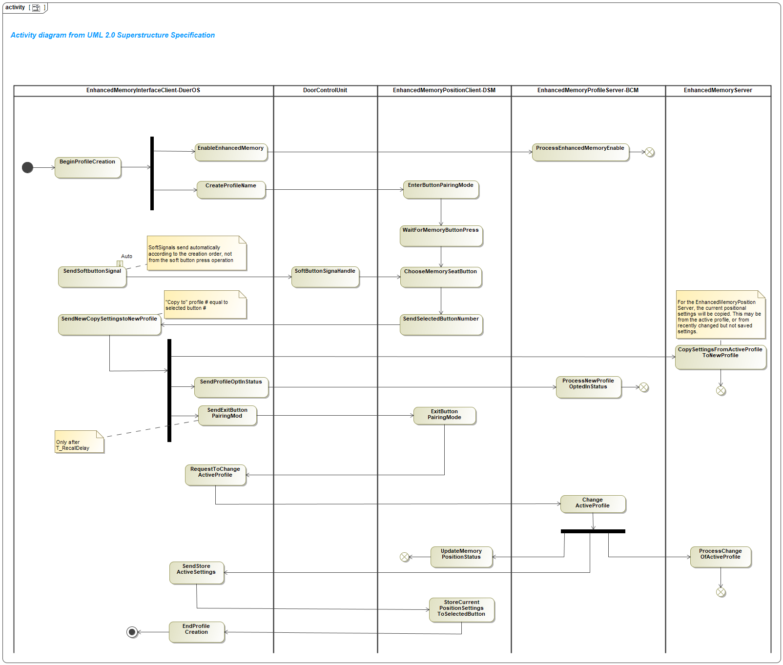

#### Sequence Diagrams

##### ENMEM-SD-REQ-199919/B-Create Driver Profile (A Happy Path)

Constraints

Pre-Condition

Ignition_Status = Run

Vehicle transmission is in Park OR vehicle speed is less than the Driving Restriction threshold*

Maximum number of Driver Profiles has not yet been reached

*Driving Restriction threshold is defined in DRIVE-RESv2-FUR-REQ-025157-HMI Driving Restriction

Scenarios

Normal Usage

The driver chooses to create a new Driver Profile and save pre-settings (positional and non-positional) in current Driver Profile.

Post-Condition

Enhanced Memory feature is enabled

A new Driver Profile is created

The pre-settings (positional and non-positional) are associated with current profile.

Sequence Diagram

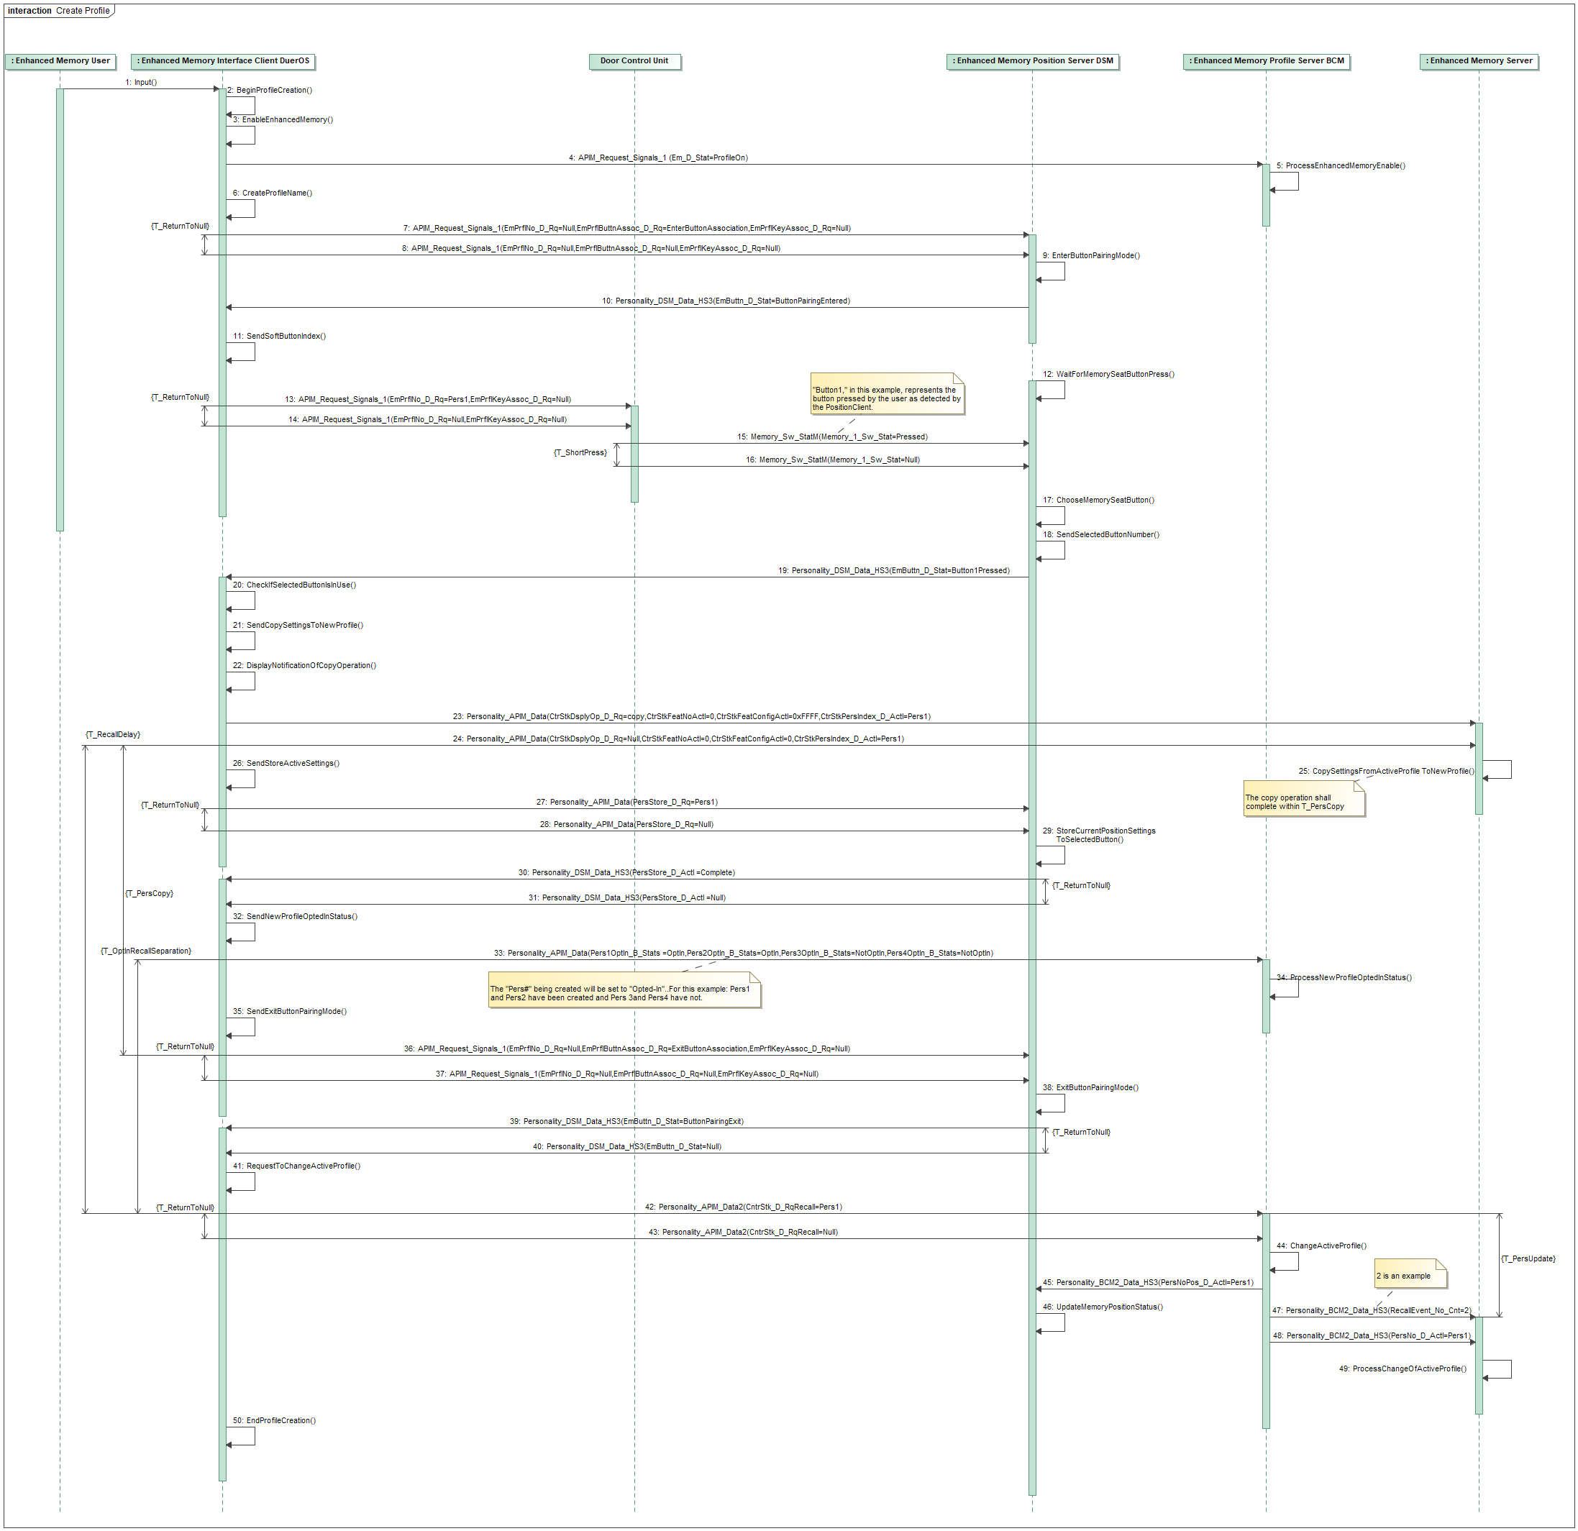

*Note: The Profile creating order, if any profile deleted, EnhancedMemoryInterfaceClient need keep the PersIndex.*

*For example: Driver creates 3 profile A, B and C. A.PersIndex=1, B.PersIndex=2, C.PersIndex=3. If we delete Profile B, and new created profile D, the result is as below:*

*A.PersIndex=1, C.PersIndex=3, D.PersIndex=2.*

##### ENMEM-TMR-REQ-xxx/x-T_ShortPress

|  |  |  |  |  |  |
| --- | --- | --- | --- | --- | --- |
| **Name** | **Description** | **Units** | **Range** | **Resolution** | **Default** |
| T_ShortPress | T_ShortPress indicate the button short press time duration for button association | msec | 50-1500 | 5 | 100 |

## ENMEM-FUN-REQ-xxx/x-Dialog

### Dialog Function Description

With a active driver profile, if the driver adjusts the left/right mirror or seat position, DuerOS shall display three options: ‘Save’, ’Restore’ and ‘Cancel’.

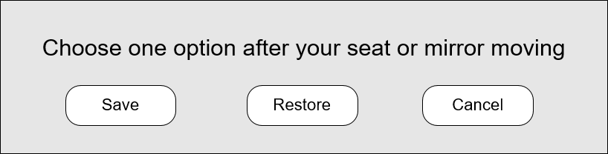

### Use Cases

#### ENMEM-UC-REQ-xxx/x-Dialog display after seat position adjustment

|  |  |
| --- | --- |
| **Actors** | Vehicle Occupant |
| **Pre-conditions** | The Ignition Status is in Run  The vehicle transmission is in Park OR vehicle speed is less than the Driving Restriction threshold* for a manual transmission  Profile A active. |
| **Scenario Description** | The driver adjusts the seat position |
| **Post-conditions** | DuerOS display dialog ‘Save’, ‘Restore’ and ‘Cancel’ |
| **List of Exception Use Cases** | If there no active driver profile present, DuerOS shall not display dialog. |
| **Interfaces** | Personalization Interface |
| **Notes** | *Driving Restriction threshold is defined in DRIVE-RESv2-FUR-REQ-025157-HMI Driving Restriction |

### Requirements

#### ENMEM-REQ-xxx/x-Dialog Precondition

One profile active is the precondition of Dialog function.

*Note: Except the vehicle profile.*

#### ENMEM-REQ-xxx/x-Save Function

If driver chooses the ‘save’ option, DuerOS shall send the save command to DCU, DCU will transfer the command to DSM. So that, the adjusted position will be saved in the current profile.

Also, the DuerOS need show a save progress bar after save button click and stop it when receive the ‘PersStore_D_Actl=Complete’ or 3s timeout.

Note: Because there must be a positional operation before the appearance of save, even if the complete is not received within 3s, the save popup will disappear without any problem, and the next time the save will be prompted again

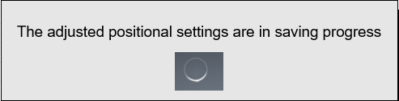

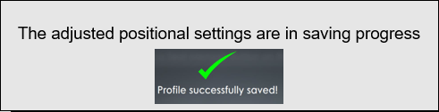

#### ENMEM-REQ-xxx/x-Restore Function

If driver chooses the ‘Restore’ option, DuerOS shall send the restore command to BCM, BCM will broadcast the current profile recall command to DSM and Enhanced Memory Servers. So that, the adjusted position will be restored in current profile.

#### ENMEM-REQ-xxx/x-Cancel Function

If driver chooses the ‘Cancel’ option, DuerOS shall cancel the dialog, and back to the original screen.

### White Box View

#### Activity Diagrams

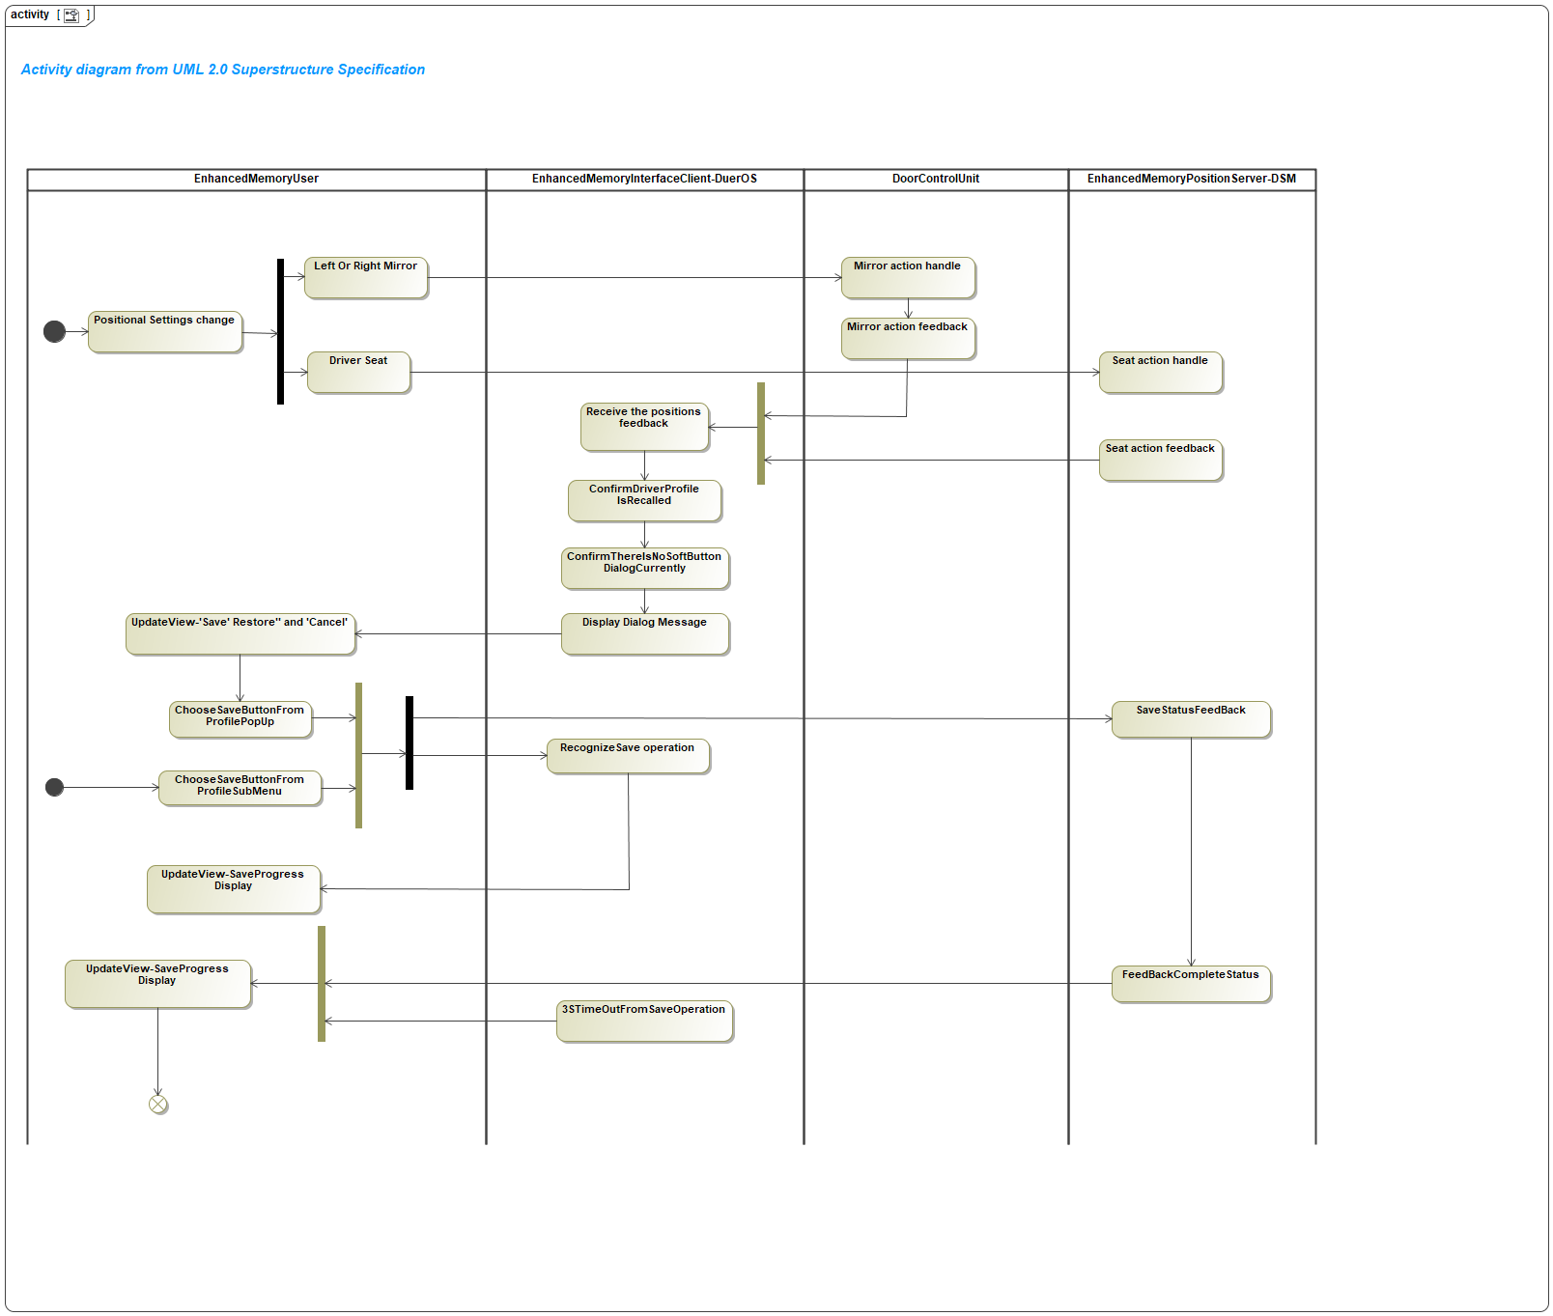

#### Sequence Diagrams

##### ENMEM-SD-REQ-xxx/x-DuerOS dialog after positional settings changed

Constraints

Pre-Condition

One driver profile is in activate state.

Scenarios

Normal Usage

The user adjusts the left/right mirrors or seat position.

Post-Condition

DuerOS display three options: ‘Save’, ’Restore’ and ‘Cancel’.

Sequence Diagram

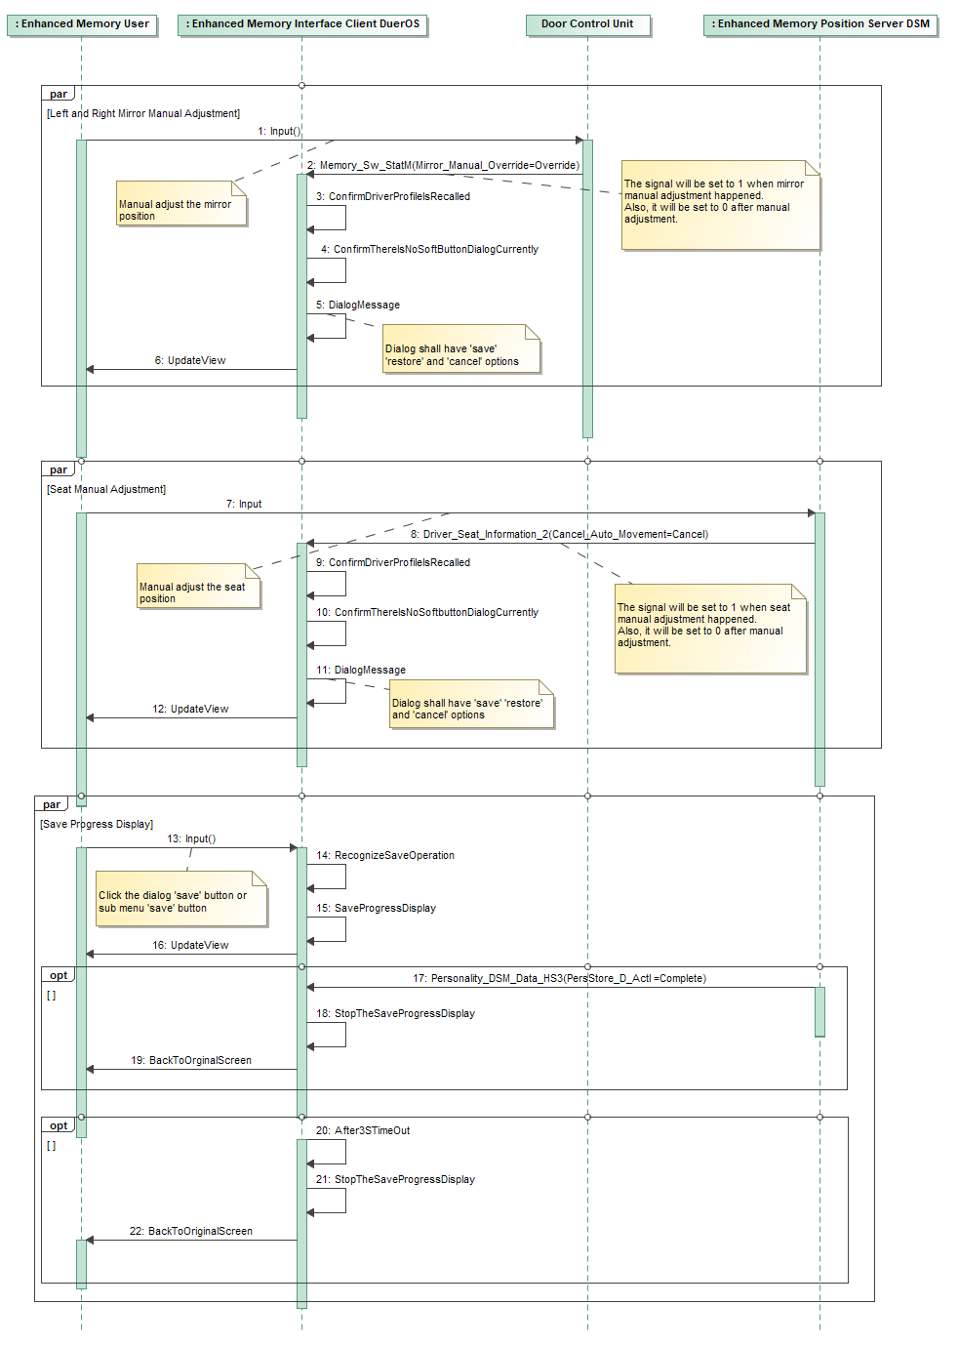

## ENMEM-FUN-REQ-xxx/x-Save

### Save function description

Save the newest positional settings to the active profile.

### Use Cases

#### ENMEM-UC-REQ-xxx/x-Save the newest positional settings to the current profile

|  |  |
| --- | --- |
| **Actors** | Vehicle Occupant |
| **Pre-conditions** | The Ignition Status is in Run  The vehicle transmission is in Park OR vehicle speed is less than the Driving Restriction threshold* for a manual transmission  Profile A is active. |
| **Scenario Description** | 1. The driver adjusts the seat and mirrors position  2. The driver chooses the ‘save’ button after dialog displayed |
| **Post-conditions** | The adjusted seat and mirrors position are stored in profile A |
| **List of Exception Use Cases** | If there no active driver profile present, DuerOS shall not display dialog. |
| **Interfaces** | Personalization Interface |
| **Notes** | *Driving Restriction threshold is defined in DRIVE-RESv2-FUR-REQ-025157-HMI Driving Restriction |

### Requirement

#### ENMEM-REQ-xxx/x-Save entrance

Driver can access the save soft button from sub-menu or dialog.



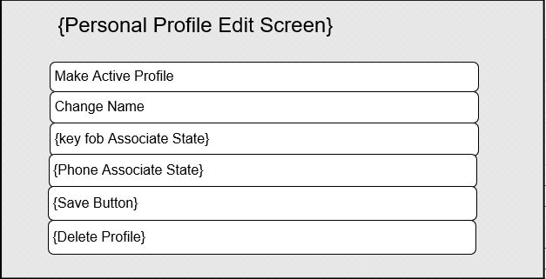

#### ENMEM-REQ-xxx/x-DuerOS show save progress bar

DuerOS shall show save progress bar after save operation and stop it when receive PersStore_D_Actl=complete or 3s timeout. Refer the 5.14.2.2 ENMEM-REQ-xxx/x-Save Function

### White Box View

#### Activity Diagrams

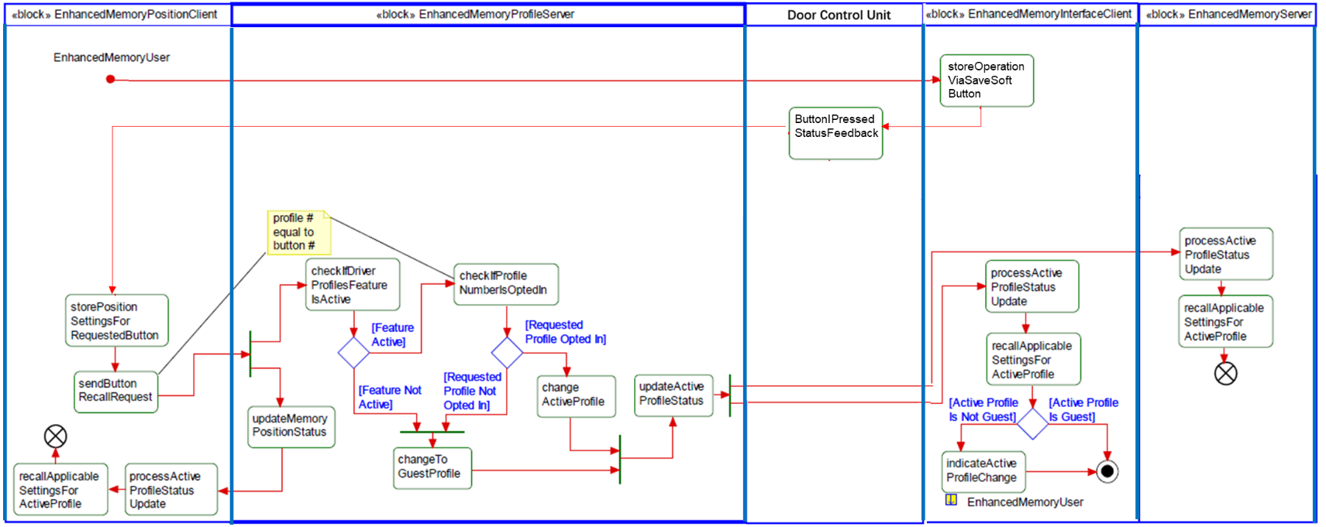

#### Sequence Diagram

##### Click save soft button after positional settings changed

**Constraints**

**Pre-Condition**

One profile is in activate state. And the user adjusts the left/right or seat position.

**Scenarios**

**Normal Usage**

Driver click the save soft button from DuerOS dialog.

**Post-Condition**

The newest positional settings are saved in the current profile.

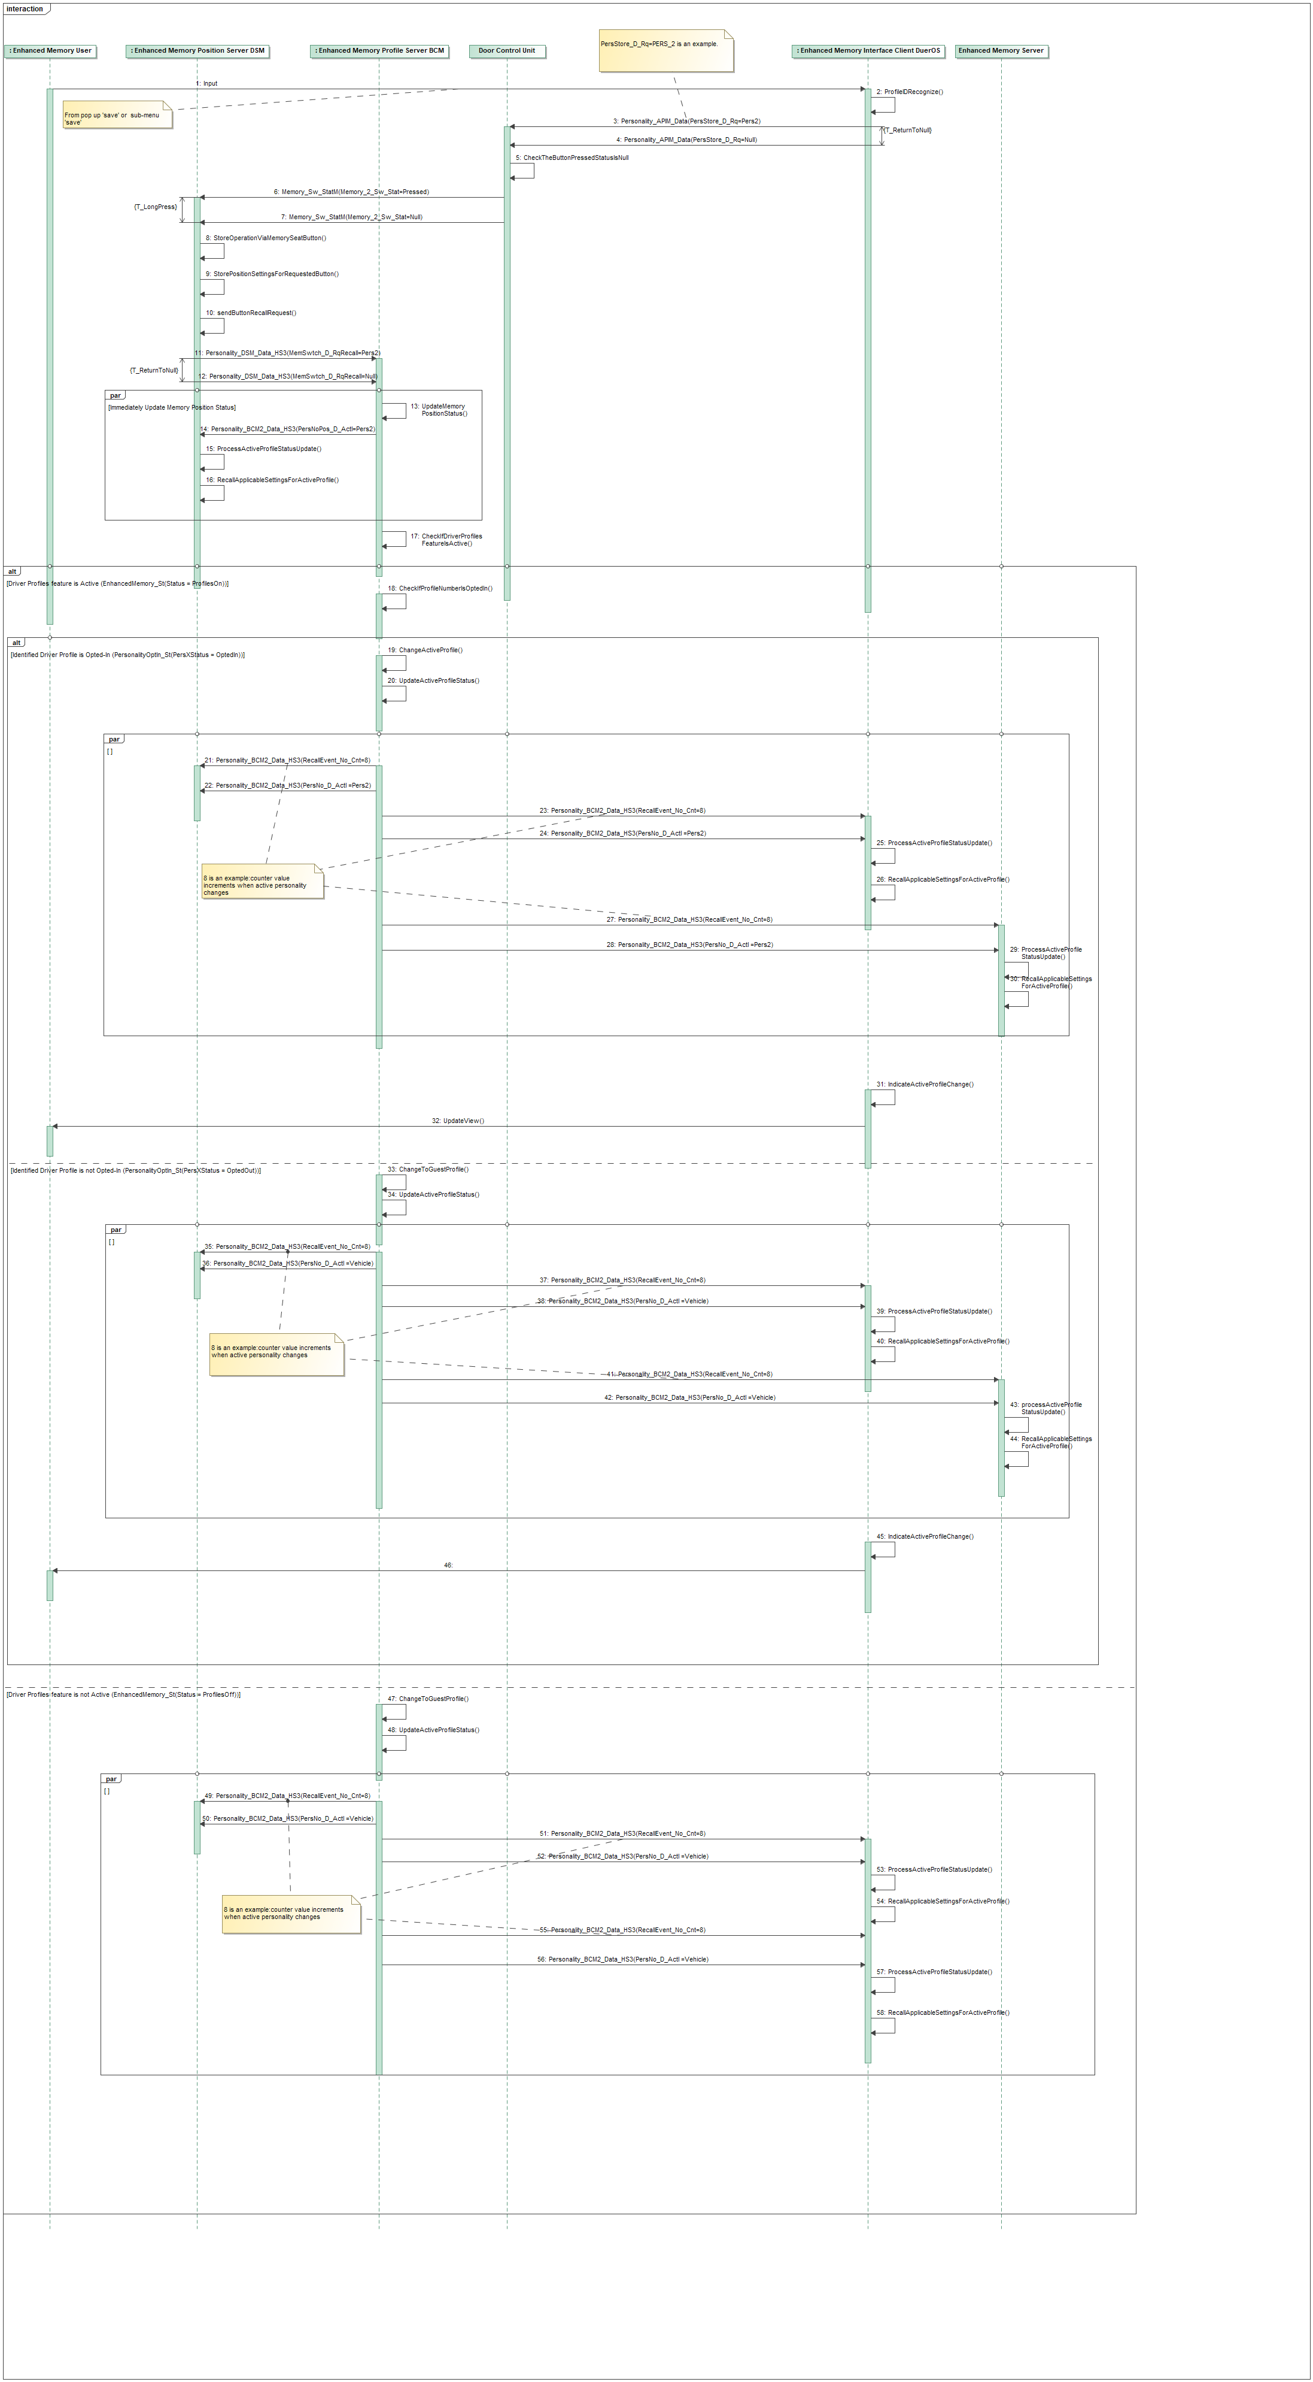

##### ENMEM-TMR-REQ-xxx/x-T_LongPress

|  |  |  |  |  |  |
| --- | --- | --- | --- | --- | --- |
| **Name** | **Description** | **Units** | **Range** | **Resolution** | **Default** |
| T_LongPress | T_LongPress indicate the button long press time duration for saving operation | msec | 1500-3000 | 5 | 2000 |

##### ENMEM-TMR-REQ-xxx/x-CheckTheButtonPressedStatusIsNull

DCU shall confirm the signal ‘EmButtn_D_Stat’ equal to Null in the save sequence diagram.

## ENMEM-FUN-REQ-xxx/x-Restore

### Restore function description

If driver choose the Restore option from the dialog, the DuerOS need send the current profile recall command to BCM. And all the changed positional settings will be restored to the settings previously stored in current profile.

### Use Cases

#### ENMEM-UC-REQ-xxx/x-Restore the mirrors and seat position

|  |  |
| --- | --- |
| **Actors** | Vehicle Occupant |
| **Pre-conditions** | The Ignition Status is in Run  The vehicle transmission is in Park OR vehicle speed is less than the Driving Restriction threshold* for a manual transmission  Profile A is active. |
| **Scenario Description** | 1.The driver adjusts the seat or mirror position  2.The driver chooses the ‘Restore’ button after dialog displayed |
| **Post-conditions** | The mirrors and seat position are restored to the settings stored in profile A previously |
| **List of Exception Use Cases** | If there no active driver profile present, DuerOS shall not display dialog. |
| **Interfaces** | Personalization Interface |
| **Notes** | *Driving Restriction threshold is defined in DRIVE-RESv2-FUR-REQ-025157-HMI Driving Restriction |

### Requirement

#### ENMEM-REQ-xxx/x-Restore entrance

Driver can access the Restore option from the dialog:



#### ENMEM-REQ-xxx/x-Restore times

Pressing the ‘Restore’ button will send the recall command each time.

*Note: Restore function is same as ‘Sign into Driver Profile via HMI menu’ function, there are no times limit for recall event of the same profile.*

### White Box View

#### Activity Diagrams



#### Sequence Diagram

##### Click restore soft button after positional settings changed

**Constraints**

**Pre-Condition**

One profile is in activate state. And the user adjusts the left/right or seat position.

*Note: for this example, the current profile index is Pers_3*

**Scenarios**

**Normal Usage**

Driver click the restore soft button from DuerOS dialog.

**Post-Condition**

The positional settings will be restored to the settings previously stored in the driver profile.

